**Test 2 M349R Juan Acosta**

**Take home problem. JA45384**

Part 1

(7 points) (Notes and Problem from “The Statistical Sleuth, 3rd”)

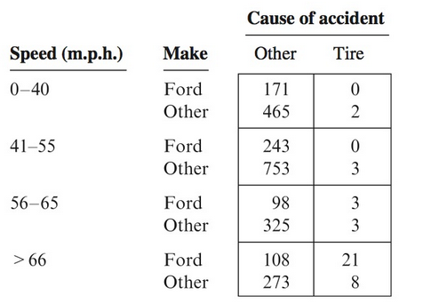Tire Related Fatal Accidents and Ford Sports Utility Vehicles. The table below shows the numbers of compact sports utility vehicles involved in fatal accidents in the United States between 1995 and 1999, categorized according to travel speed, make of the car (Ford or other), and cause of the accident (tire-related or other).

1. From this table, test whether the odds of a tire-related fatal accident depend on whether the sports utility vehicle is a ford after accounting for travel speed.
2. Also estimate the excess number of Ford tire-related accidents.

**Answer:**

|  |  |  |  |  |  |  |  |  |  |
| --- | --- | --- | --- | --- | --- | --- | --- | --- | --- |
| **Speed (m.p.h)** | **Make** | **Other** | **Tire** | **Expected** | **Excess** | **Variance** | **Z-statistic** | **1-Sided P-val** | **Odds Ratio** |
| 0-40 | Ford | 171.5 | 0.5 | 0.80625 | -0.30625 | 0.58773 | -0.39947 | 0.65522818 | 0.5428571 |
|  | Other | 465.5 | 2.5 |  |  |  |  |  |  |
| 41-55 | Ford | 243.5 | 0.5 | 0.97502 | -0.47502 | 0.73514 | -0.55403 | 0.71021945 | 0.4420651 |
|  | Other | 753.5 | 3.5 |  |  |  |  |  |  |
| 56-65 | Ford | 98 | 3 | 1.41259 | 1.587413 | 1.0674 | 1.536475 | 0.06221093 | 3.3163265 |
|  | Other | 325 | 3 |  |  |  |  |  |  |
| >66 | Ford | 108 | 21 | 9.12439 | 11.87561 | 5.82543 | 4.920304 | 4.3205E-07 | 6.6354167 |
|  | Other | 273 | 8 |  |  |  |  |  |  |
|  |  |  |  |  | **Excess** | **Variance** | **Z-statistic** | **1-Sided P-val** |  |
|  |  |  |  | Total | 12.68175 | 8.2157 | 4.424424 | 4.835E-06 |  |
|  |  |  |  |  |  |  |  |  |  |
|  |  |  |  | w_hat | 3.939705 |  |  |  |  |

1. After speed has been accounted for, the odds of a compact sports utility vehicle being in a fatal accident due to tire-related reasons are estimated to be 3.94 times greater if the make was Ford than any other make.
2. Nearly 13 more Ford compact sports utility vehicles in fatal accidents were determined to have had tire-related accidents than would have been expected if the odds of being in a tire-related accidents and other type of accidents were the same for Ford and other make compact sports utility vehicles.

Part 2

(8 points) (Notes II)

1. Use Logistic Regression in order to test for conditional independence of Make and Cause of Fatal Accident while controlling for Speed. Note: Use the Haldane-Anscombe correction on the first two tables.

**Answer:**

1. From the excel table we can see that the odds ratio varies from group to group while accounting for speed. Nonetheless, running the logistic regression on SAS and looking at the coefficient of make, we can reject the hypothesis that the coefficient of make is equal to zero Moreover, looking at the odds ratio with Wald confidence intervals we can see that there is no homogeneous association. Therefore, it is approximately 1.35 times more likely that if the accident was tire related that the car was a Ford than any other make while controlling for Speed.

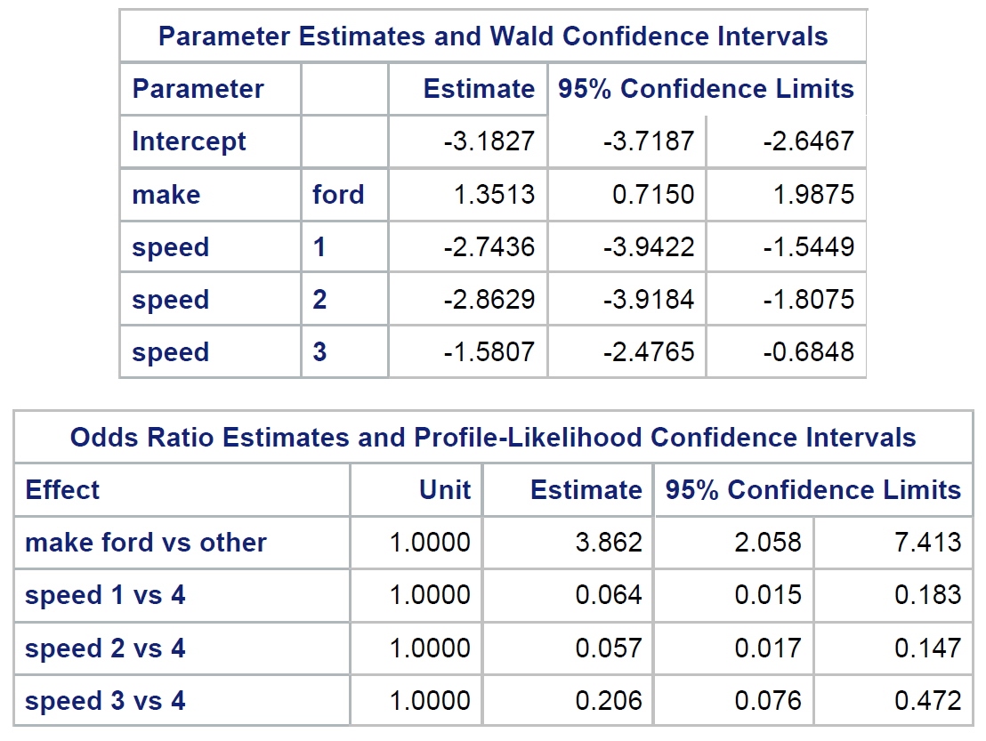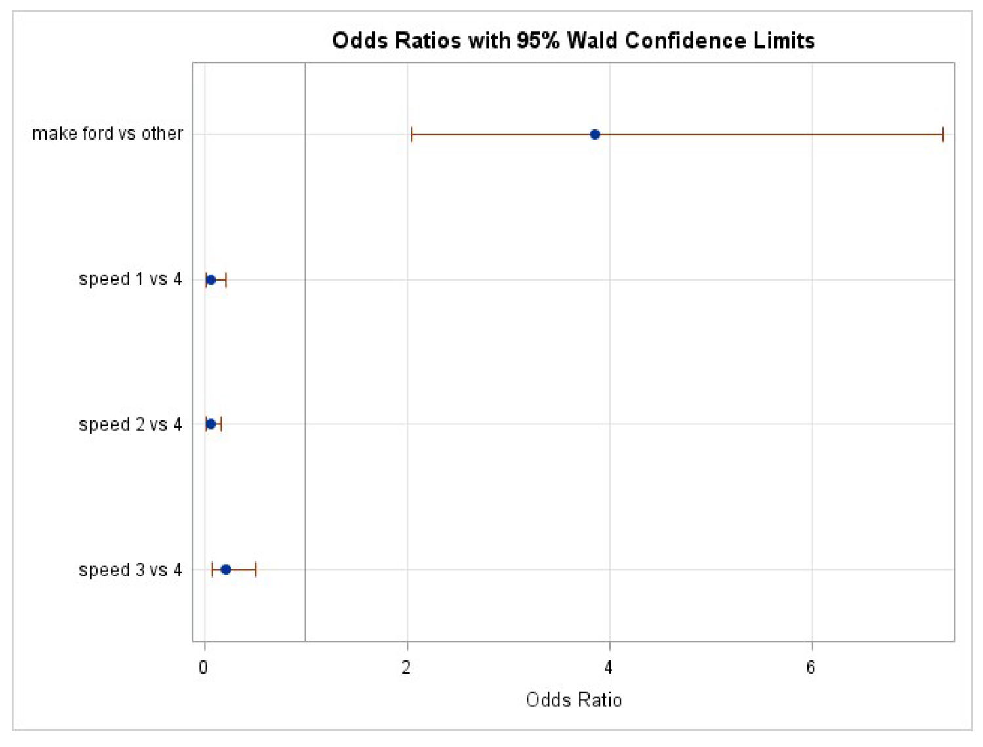



Code:

**data** ford;

input speed $ make $ y total @@;

datalines;

1 ford 0.5 172 1 other 2.5 468 2 ford 0.5 244 2 other 3.5 757 3 ford 3 101 3 other 3 328 4 ford 21 129 4 other 8 281

;

**run**;

**proc** **genmod** data=ford;

class speed make;

model y/total=make speed/dist=bin type3 lrci residuals obstats;

**run**;

**proc** **logistic**;

class speed make/param=ref;

model y/total=make speed/aggregate scale=none clparm=both clodds=both;

**run**;